1. **Experiment:** Cell proliferation assessment by cell counting method
2. **Time:** 2025.02.10-2025.02.29
3. **Member:** Xudong Tang, Yang Jin, Binxuan Zhang, Kaiqing Zhang, Xuantong Liu
4. **Materials:** Cell culture flasks, automated cell counter, pipettes and pipette tips, cell culture medium, incubator, centrifuge, cell culture dishes, sterile tubes or containers, growth curve plotting software, IL-2
5. **Method:**
6. Cell Counting
7. After stimulation with IL-2, B34G35R, B51G35R, or B51G9, αMSLN CAR-NK cells and αHER2 CAR-T cells were respectively co-cultured with tumor cells (K562).
8. Sample Collection: Place all culture flasks in cell incubator set at 37 ℃, 5%CO2. At predefined days of cell culture (Day 1 - Day 7), cell samples were collected from each culture flask, and resuspended thoroughly.
9. Cell Counting: An aliquot of each cell sample was taken, and cells were counted using an automated cell counter. Recorded the cell numbers, the total cell number was recorded for each time point.
10. Calculation of Fold Expansion: The fold expansion of cells was calculated by comparing the cell numbers at different time points to the initial cell count (Day 0). The fold increase was determined using the formula: Fold Expansion = Cell Number at Time point t/Initial Cell Number (Day 0).
11. Plotting the Growth Curve: Using graphing software, a cell growth curve was generated by plotting the fold expansion (y-axis) against the days of culture (x-axis). This curve was used to analyze the proliferation rate and growth kinetics of the cultured cells over time.
12. **Result:**

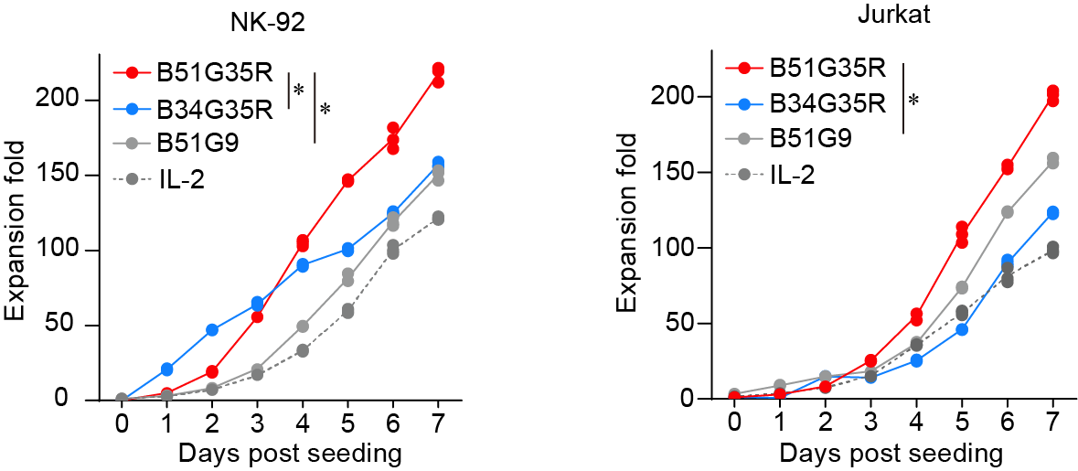

**Figure.1** Proliferation activity of NK-92 cells and Jurkat cells in response to B34G51, B34G35, B51G9 and IL-2 stimulation (\**P* < 0.05 compared with B34G35 and B51G9). Data are presented as mean ± SD of three independent biological replicates.